# Exercises: PostgreSQL Table Relations

**Submit your solutions** to the SoftUni [Judge Contest](https://alpha.judge.softuni.org/Contests/Table-Relations-Exercise/4109).

**Ask** **your** **questions** here: [https://www.slido.com](https://www.slido.com/) by entering the course code **#python-db**

For the upcoming assignments, let us direct our attention toward the implementation of the **PRIMARY KEY**.

## PRIMARY KEY

### a. Create a table

Create a new table called **"products"** that includes a column named **"product_name"** which has **a maximum character limit of 100**.

Insert the following values into the **"products"** table: **'Broccoli'**, **'Shampoo'**, **'Toothpaste'**, and **'Candy'**.

### Example

|  |
| --- |
| **product_name character varying (100)** |
| Broccoli |
| Shampoo |
| Toothpaste |
| Candy |

### b. Define the primary key when changing the existing table structure

The newly created table **does not have a unique identifier**. To add a **PRIMARY KEY**, use the **ALTER TABLE** statement.

Submit your queries for the two-step task in the Judge system.

### Example

|  |  |
| --- | --- |
| **product_name character varying (100)** | **id [PK] integer** |
| Broccoli | 1 |
| Shampoo | 2 |
| Toothpaste | 3 |
| Candy | 4 |

## Remove Primary Key

Write an SQL statement to **DROP CONSTRAINT** from the **"products"** table.

**\*\*\*** Note, if a name is not specified explicitly for the primary key constraint, PostgreSQL will assign a default name to it. The default name for the primary key constraint is **"table-name_pkey"**.

Submit your query for this task in the Judge system.

### Example

|  |  |
| --- | --- |
| **product_name character varying (100)** | **id integer** |
| Broccoli | 1 |
| Shampoo | 2 |
| Toothpaste | 3 |
| Candy | 4 |

*Let's redirect our attention to the* ***One-To-One Relationship*** *for the tasks ahead.*

1. **Customs**

To fulfill this assignment, you are required to establish a new **database** named **"****customs_db"** and produce two tables inside it, named **"passports"** and **"people"**.

### a. Create and Insert Passports Table

Wright a SQL statement to create a new table called **"passports"** with two columns, **"id"** and **"nationality"**. The **"id"** column should be an **automatically incremented primary key, starting at 100 and incrementing by 1**. The **"nationality"** column should have a **maximum character limit of 50**.

Then, insert three rows into the **"passports"** table with values **'N34FG21B'**, **'K65LO4R7'**, and **'ZE657QP2'** for the **"nationality"** column.

**\*\*\*** Note, when using the **GENERATED AS IDENTITY** constraint, a **SEQUENCE** object is utilized, which allows for the **specification of sequence options for system-generated values**. The following syntax can be used to specify these options: **(START WITH start_from_number INCREMENT BY increment_value)**.

### Example

|  |  |
| --- | --- |
| **id** | **nationality** |
| 100 | N34FG21B |
| 101 | K65LO4R7 |
| 102 | ZE657QP2 |

## b. Create and Insert People Table

In the next step of this task, your objective is to create a new table called **"people"** which includes the following columns:

* **"id"** column that is an **automatically incremented SERIAL PRIMARY KEY**;
* **"first_name"** column with a **maximum length of 50** characters and is of type **VARCHAR**;
* **"salary"** column which is specified to the **second decimal place** and has a **maximum of 10 digits**;
* **"passport_id"** column of type **INT** which is established as a **FOREIGN KEY** constraint and **refers** to the **"id"** column of the **"passports"** table.

After creating the **"people"** table, you need to insert three rows into it, each row should have values for the **"first_name"**, **"salary"**, and **"passport_id"** columns:

* **('Roberto', 43300.0000, 101)**
* **('Tom', 56100.0000, 102)**
* **('Yana', 60200.0000, 100)**

Submit your queries for the two-step task in the Judge system.

### Example

|  |  |  |  |
| --- | --- | --- | --- |
| **id** | **first_name** | **salary** | **passport_id** |
| 1 | Roberto | 43300.00 | 101 |
| 1 | Tom | 56100.00 | 102 |
| 2 | Yana | 60200.00 | 100 |

*It is time to focus our attention on the* ***One-To-Many/Many-To-One Relationship*** *for the upcoming assignments.*

## 4. Car Manufacture

To complete this task, you will need to create a **database** called **"car_manufacture_db"** that consists of **three tables**: **"manufacturers"**, **"models"**, and **"production_years"**.

### a. Create Tables

The **"manufacturers"** table should have a column, which is **"name"**. In the **"models"** table, you should include columns for **"model_name"** and **"manufacturer_id"**. The **"production_years"** table should contain information about **"established_on"** and **"manufacturer_id"**. You are free to **select the data type** for each column, but it is crucial to ensure that each column has a **unique identifier**. Additionally, it is important to **correctly set up the foreign keys**. Note that the **"models"** identifier should **start at 1000 and increment by 1**.

### b. Insert Data

Add data to the tables in the following manner:

|  |  |
| --- | --- |
| **manufacturers** | |
| **name** | |
| BMW | |
| Tesla | |
| Lada | |
|  |  |
|  |  |

|  |  |
| --- | --- |
| **models** | |
| **model_name** | **manufacturer_id** |
| X1 | 1 |
| i6 | 1 |
| Model S | 2 |
| Model X | 2 |
| Model 3 | 2 |
| Nova | 3 |

|  |  |
| --- | --- |
| **production_years** | |
| **established_on** | **manufacturer_id** |
| 1916-03-01 | 1 |
| 2003-01-01 | 2 |
| 1966-05-01 | 3 |

Submit your queries for the two-step task in the Judge system.

## 5. Car Manufacture E/R Diagram[1]**

Generate an **Entity/Relationship Diagram** for the three tables created in the **Car Manufacture** task.

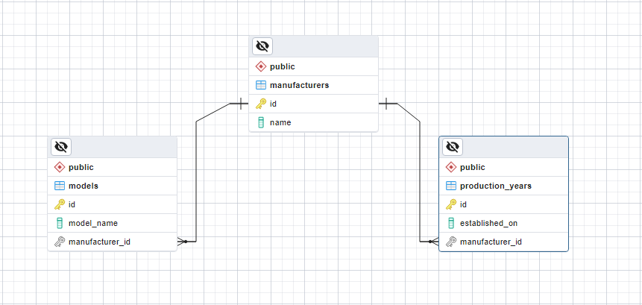

## 6. Photo Shooting

To finish this assignment, you need to create a database called "**photo_shooting_db**" that comprises two tables: "**customers**" and "**photos**".

The "**customers**" table should contain two columns - "**name**" and "**date**". In the "**photos**" table, you should include columns for "**url**" and "**place**". The **data type** for each column can be **chosen according to your preference**, but it is essential to ensure that each column has a **unique identifier**. Moreover, correctly setting up the **foreign keys** is crucial.

Insert data into the tables in the format shown below:

|  |  |  |  |  |  |  |  |  |  |  |  |  |  |  |  |  |  |  |  |  |  |  |  |  |  |  |  |  |  |  |  |  |  |
| --- | --- | --- | --- | --- | --- | --- | --- | --- | --- | --- | --- | --- | --- | --- | --- | --- | --- | --- | --- | --- | --- | --- | --- | --- | --- | --- | --- | --- | --- | --- | --- | --- | --- |
| |  |  | | --- | --- | | **customers** | | | **name** | **date** | | Bella | 2022-03-25 | | Philip | 2022-07-05 | | |  |  |  | | --- | --- | --- | | **photos** | | | | **url** | **place** | **customer_id** | | bella_1111.com | National Theatre | 1 | | bella_1112.com | Largo | 1 | | bella_1113.com | The View Restaurant | 1 | | philip_1121.com | Old Town | 2 | | philip_1122.com | Rowing Canal | 2 | | philip_1123.com | Roman Theater | 2 | |

Submit your query for this task in the Judge system.

## 7. Photo Shooting E/R Diagram[2]**

Create an **Entity/Relationship Diagram** for the **"customers"** and **"photos"** tables created in the previous task.

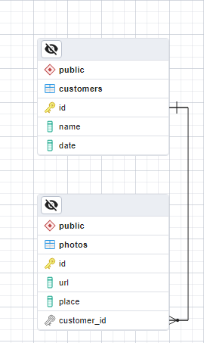

*Let's focus on the* ***Many-To-Many Relationship*** *for the upcoming assignments.*

## 8. Study Session [Solve with AI]

To complete this task, create a database named **"study_session_db"** that includes the following tables: **"students"**, **"exams"**, **"study_halls"**, and **"students_exams"**.

The **"students"** table should have a column for **"student_name"**. In the **"exams"** table, include a column for **"exam_name"**. The **"study_halls"** table should contain columns for **"study_hall_name"** and **"exam_id"**. The **"students_exams"** table should have columns for **"student_id"** and **"exam_id"**. You are free to choose the **appropriate data type** for each column but ensure each has a **unique identifier**. Note that the **"exams"** identifier should **start at 101 and increment by 1**. It is important to correctly set up the **foreign keys**.

Insert data into the tables in the format shown below:

|  |  |  |  |  |  |  |  |  |  |  |  |  |  |  |  |  |  |  |  |  |  |  |  |  |  |  |  |  |  |  |  |  |  |  |  |  |  |  |  |  |  |  |  |  |  |  |  |  |  |  |  |  |  |  |  |  |  |  |  |  |  |  |  |  |  |  |  |
| --- | --- | --- | --- | --- | --- | --- | --- | --- | --- | --- | --- | --- | --- | --- | --- | --- | --- | --- | --- | --- | --- | --- | --- | --- | --- | --- | --- | --- | --- | --- | --- | --- | --- | --- | --- | --- | --- | --- | --- | --- | --- | --- | --- | --- | --- | --- | --- | --- | --- | --- | --- | --- | --- | --- | --- | --- | --- | --- | --- | --- | --- | --- | --- | --- | --- | --- | --- |
| |  |  | | --- | --- | | **students** | | | **student_name** | | | Mila | | | Toni | | | Ron | | |  |  | |  |  |  | | --- | --- | | **students_exams** | | | **student_id** | **exam_id** | | 1 | 101 | | 1 | 102 | | 2 | 101 | | 3 | 103 | | 2 | 102 | | 2 | 103 | | |  |  | | --- | --- | | **exams** | | | **exam_name** | | | Python Advanced | | | Python OOP | | | PostgreSQL | | |  |  | | |  |  |  | | --- | --- | --- | | **study_halls** | | | | **study_hall_name** | | **exam_id** | | Open Source Hall | | 102 | | Inspiration Hall | | 101 | | Creative Hall | | 103 | | Masterclass Hall | | 103 | | Information Security Hall | | 103 | |  |  |  | |

Submit your query for this task in the Judge system.

## 9. Study Session E/R Diagram[3]**

Create an **Entity/Relationship** Diagram for the "**study_session_db**" database, which includes four tables: "**students**", "**exams**", "**study_halls**", and "**students_exams**".

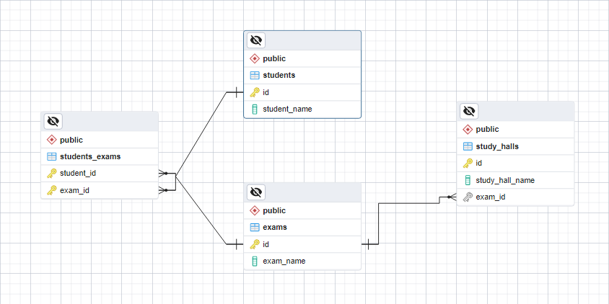

## 10. Online Store [Solve with AI]

Create a database called **"online_store_db"** using the provided **E/R Diagram**. Set up the necessary tables and ensure that their **relationships are properly defined**.

**Important**: When creating your tables, arrange the columns and foreign key constraints as shown in the diagram below.

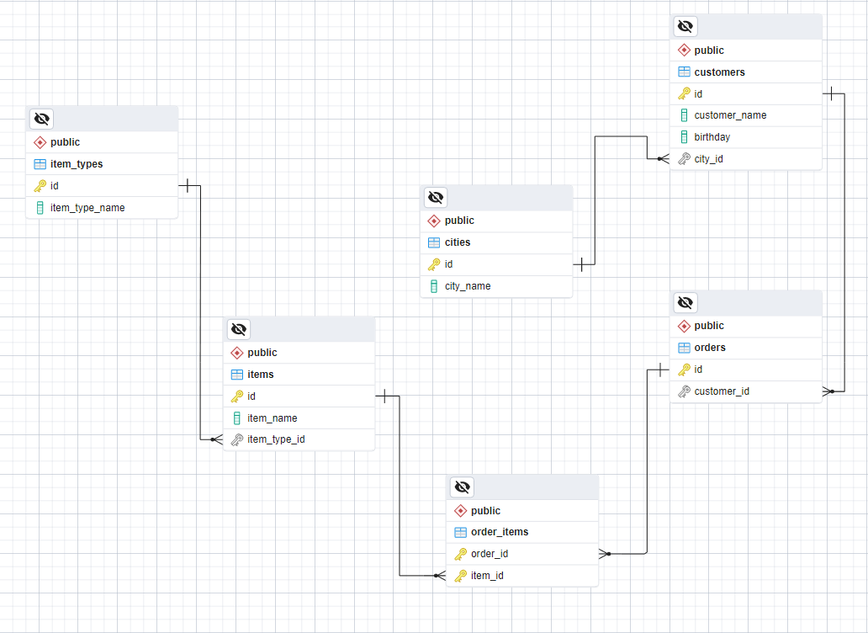

Submit your query for this task in the Judge system.

*For the upcoming tasks, let's pay more attention to* ***FOREIGN KEY*** *and its* ***Cascade Operations*** *and ensure that they are correctly implemented. We will be using a database that you are already familiar with, but for the purpose of these tasks, the data has been modified. Therefore, create a new database named* ***table_relations_geography_db****. Download the* ***05-Exercises-Table-Relations-geography_db.sql*** *file from the course instance, import it into your database's query tab, and execute the queries provided in the file.*

## 11. Delete Cascade

Let's proceed to establish the relationships and update the **"countries"** table. Locate the columns that correspond to the **"continents"** and **"currencies"** tables, and ensure that when a **record in the parent table is deleted**, corresponding **records in the child table are also deleted**.

Submit your query for this task in the Judge system.

## 12. Update Cascade

Revise the **"countries_rivers"** table by ensuring that its relationship with the **"rivers"** and **"countries"** tables is properly updated. When a row in the **parent tables is updated**, ensure that matching rows in the **child table are also updated**.

Submit your query for this task in the Judge system.

## 13. SET NULL [Solve with AI]

Write SQL queries to create two new tables: **"customers"** and **"contacts"**. The **"customers"** table should have a column for **"customer_name"**, and the **"contacts"** table should contain columns for **"contact_name"**, **"phone"**, **"email"**, and **"customer_id"**. You can choose the data type for each column based on your preference, but it's important to ensure that each table has a **unique identifier**.

To set up the **foreign keys** correctly, make sure that when a record in the **"customers"** table is **deleted**, the corresponding records in the **"contacts"** table have their **"customer_id"** value set to **NULL**. Additionally, when a row in the **"customers"** table is **updated**, ensure that matching rows in the **"contacts"** table are also **updated accordingly.**

Insert data into the tables in the format shown below:

|  |  |
| --- | --- |
| **customers** | |
| **customer_name** | |
| BlueBird Inc | |
| Dolphin LLC | |
|  |  |
| **contacts** | | | | |
| **contact_name** | | **phone** | **email** | **customer_id** |
| John Doe | | (408)-111-1234 | john.doe@bluebird.dev | 1 |
| Jane Doe | | (408)-111-1235 | jane.doe@bluebird.dev | 1 |
| David Wright | | (408)-222-1234 | david.wright@dolphin.dev | 2 |

Finally, remove the row from the **"customers"** table where the value of the **"id"** column matches **1**.

Submit your query for this task in the Judge system.

### Example

|  |  |  |
| --- | --- | --- |
| **customers** | | |
| **id** | **customer_name** | |
| 2 | Dolphin LLC | |
|  |  | |
| **contacts** | | | | | |
| **id** | **contact_name** | **phone** | | **email** | **customer_id** |
| 1 | John Doe | (408)-111-1234 | | john.doe@bluebird.dev | [null] |
| 2 | Jane Doe | (408)-111-1235 | | jane.doe@bluebird.dev | [null] |
| 3 | David Wright | (408)-222-1234 | | david.wright@dolphin.dev | 2 |

## 14. * Peaks in Rila [Solve with AI]

Retrieve data from the **"** **table_relations_geography_db"** database by joining the **"mountains"** and **"peaks"** tables using their common data. Then, display all peaks for the **"Rila"** mountain, including the **"mountain_range"**, **"peak_name"**, and **"elevation"**. Finally, sort the results in descending order by the "elevation".

Submit your query for this task in the Judge system.

### Example

|  |  |  |
| --- | --- | --- |
| **mountain_range** | **peak_name** | **elevation** |
| Rila | Musala | 2925 |
| Rila | Malka Musala | 2902 |
| Rila | Malyovitsa | 2729 |
| Rila | Orlovets | 2685 |

## 15. * Countries Without Any Rivers [Solve with AI]

Create an SQL query that retrieves data from the **"table_relations_geography_db"** database by joining the **"countries"** and **"countries_rivers"** tables based on their common data. Then, calculate the total number of countries that do not have any rivers.

**\*\*\*** Note, using a **LEFT JOIN** will ensure that all records from the **"countries"** table are included in the result set, and a **WHERE** clause will filter out rows where the **"countries_rivers"** table has no corresponding records.

Submit your query for this task in the Judge system.

### Example

|  |
| --- |
| **countries_without_rivers** |
| 184 |

1. ** This task is not required to be submitted to the Judge system and will not be considered in the final result.
2.
3.